TASK 3-Minikube Deployment Task

**Name**:SRI SURIYA S

**RollNo**:22CSL265

# Step 1: Start Minikube

Start the Minikube cluster using the following command: minikube start

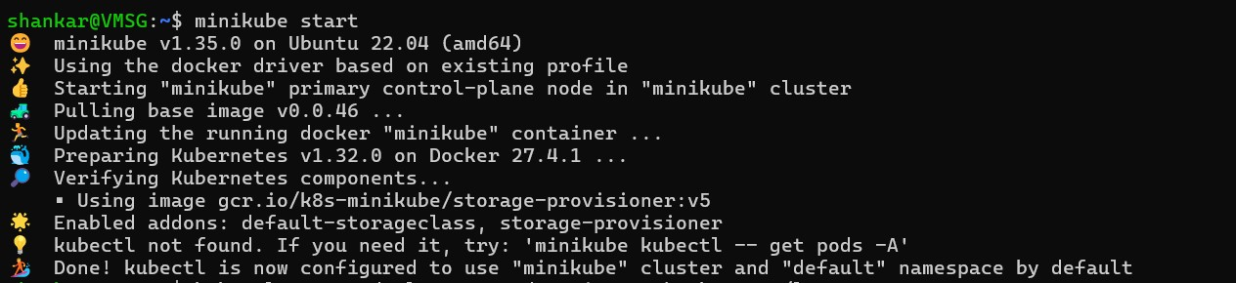

This initializes the Minikube cluster using Docker as the driver.

# Step 2: Install Kubectl

Since Kubectl is not found, install it with the following command: sudo snap install kubectl --classic

Alternatively, you can download it using curl:

 curl -LO "https://dl.k8s.io/release/$(curl -L -s

https://dl.k8s.io/release/stable.txt)/bin/linux/amd64/kubectl" sudo install -o root -g root -m 0755 kubectl /usr/local/bin/kubectl

# Step 3: Verify Kubectl Installation

Check the client version to confirm successful installation:

kubectl version –client



# Step 4: Create a Deployment

Create a deployment named `pod1` with the image `shankar4112/devops-training`: kubectl create deployment pod1 --image=shankar4112/devops-training --port=80



# Step 5: Expose the Deployment

Expose the deployment as a NodePort service: kubectl expose deployment pod1 --port=80 --type=NodePort



# Step 6: Verify the Pod

Check the running pods: kubectl get pods



# Step 7: Access the Service

Expose the service using Minikube and get the URL:

minikube service pod1

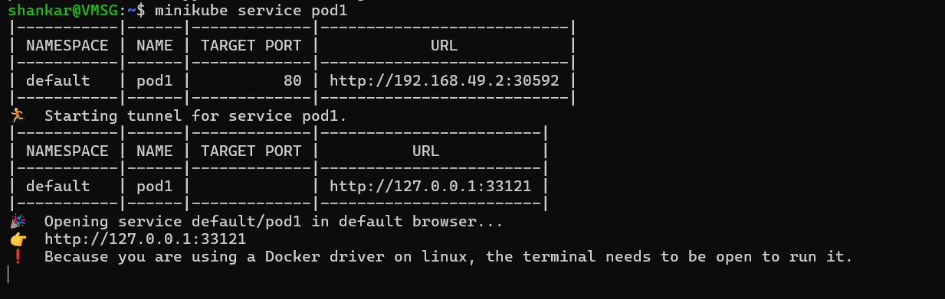

# Step 8: Output in the Web Browser

